

**CLOUD COMPUTING**

**BSE ( V-B )**

Submitted By:

Zaheena Anwar

Roll No:

2023-BSE-070

**ASSIGNMENT 01**

**Git, Gitea, GitHub, LFS, and GitHub Pages**

* Screenshot of your Gitea repository (showing README listing names & roll numbers)

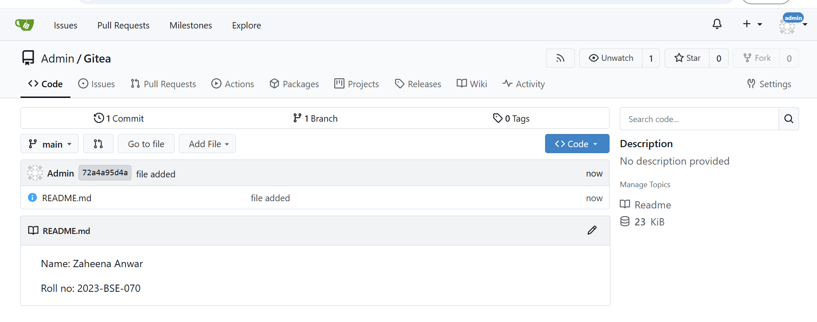

* GitHub assignment 1 repo link (with README and large files)

<https://github.com/Zaheena1/assignment-1>

* Screenshot or output of git remote -v showing both remotes

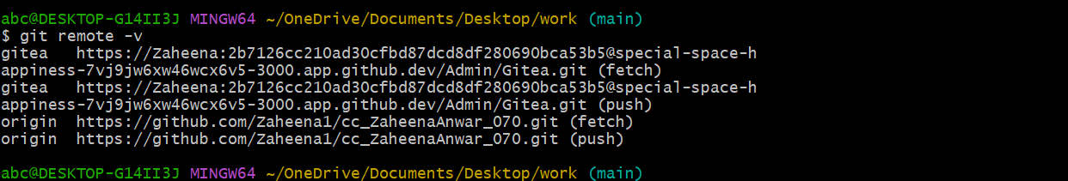

* GitHub Pages link to your CV/portfolio

<https://zaheena1.github.io/>